### A

Tribhuvan University Affiliated College

**Sagarmatha College of Science and Technology**



**A**

**Final Year Project Report**

**On**

**Online Matchmaking System**

(In partial fulfillment of the requirement for the Bachelor degree in Computer Science and Information Technology)

**Submitted to:**

Department of Computer Science and Information Technology,

Sagarmatha College of Science and Technology

Sanepa-16, Lalitpur

**Submitted by:**

Sagar K.C (Roll no 20864)

Siddharatha Khanal (Roll no 20870)

Sujan Giri (Roll no 20874)

# DECLARATION

Online Matchmaking System which is being submitted to the Department of Computer Science and Information Technology, Sagarmatha College of Science and Technology, Sanepa, Lalitpur for the fulfillment of the seventh semester as major project under the supervision of Mr. Bishnu Khadka.

This project is original and has not been submitted earlier in part or full in this or any other form to any university, here or elsewhere, for award of any degree.

…….............................

Siddharatha Khanal

Roll no 20870

…….............................

Sujan Giri

Roll no 20874

…….............................

Sagar K.C

Roll no 20864



# SUPERVISOR’S RECOMMENDATION

I hereby recommend that this project be prepared under my supervision by SAGAR K.C, SIDDHARATHA KHANAL, SUJAN GIRI entitled **ONLINE MATCHMAKING SYSTEM** in partial fulfillment of the requirements for the degree of B.Sc.CSIT Computer Science and Information Technology be processed for evaluation.

…….............................

**Bishnu Khadka**

Sagarmatha College of Science and Technology

Sanepa, Lalitpur

# ACKNOWLEDGEMENT

With a great pleasure, we present our project on the application “ONLINE MATCHMAKING SYSTEM” that functions as an online matchmaking platform.

We would like to thank Mr. Bishnu Khadka, our Project Supervisor, who with his continuous support and effort, helped us create this project. Similarly, we cannot stay without expressing our gratitude to Mr. Ramesh Shrestha, the Principle of Sagarmatha College, for providing us an opportunity to perform out research activities and come up with a working solution that would be beneficial for a large mass of people.

We are thankful and fortunate enough to get constant support from our colleagues and teaching staff of B.Sc.CSIT department, which helped us, complete our project. We would also like to extend our regards to all the non-teaching staff of B.Sc.CSIT department for their timely support.

Lastly, we are thankful to all the helping hands who always welcomed us with their warm support at the time when we needed them. Also, we would like to apologies for the mistakes that may have been committed in this project report.

Sagar K.C (Roll no 20864)

Siddharatha Khanal (Roll no 20870

Sujan Giri (Roll no 20874)

# ABSTRACT

Renai is a mobile application designed to facilitate online matchmaking and connect individuals based on shared interests, preferences, and compatibility. The application provides a platform for users to create accounts, browse profiles, and engage in meaningful conversations with potential matches.

Upon logging in, users can explore a diverse range of profiles presented with the help of a recommendation algorithm, ensuring a higher likelihood of finding compatible partners. The application employs a voting system where users can express their interest by voting up or down on profiles. When a user votes up another user, a notification is sent to the potential match, allowing them to accept or decline the connection request. Upon acceptance, both users gain access to a dedicated chat feature, enabling communication and fostering meaningful connections.

Renai goes beyond traditional matchmaking by offering an additional search functionality, allowing users to search for specific individuals based on input interests. Users can find matches tailored to their preferences.

Furthermore, Renai also incorporates profile management features, empowering users to update and customize their profiles with essential details, interests, and photographs. The application also includes an administration system that verifies user logins and registrations while providing administrative oversight to ensure a safe and secure environment for users.

In conclusion, Renai offers a user-friendly and efficient online matchmaking platform, enabling users to connect with like-minded individuals, build relationships, and engage in meaningful conversations. With its recommendation algorithm, chat functionality, advanced search capabilities, and robust profile management features, Renai strives to create a positive and enjoyable matchmaking experience for its users.

# TABLE OF CONTENTS

Contents

ACKNOWLEDGEMENT IV

ABSTRACT V

LIST OF ABBREVIATION VIII

LIST OF FIGURES IX

LIST OF TABLES X

CHAPTER 1 INTRODUCTION 1

1.1 BACKGROUND 1

1.2 PROBLEM 2

1.3 OBJECTIVES 2

1.4 SCOPE 2

1.5 LIMITATIONS 2

CHAPTER 2 LITERATURE REVIEW 3

CHAPTER 3: SYSTEM ANALYSIS 6

3.1 REQUIREMENT ANALYSIS 6

3.1.1 FUNCTIONAL REQUIREMENT 6

3.1.2 NON FUNCTIONAL REQUIREMENTS 9

3.2 FEASIBILITY STUDY 10

3.2.1 ECONOMICAL FEASIBILITY 10

3.2.2 TECHNICAL FEASIBILITY 10

3.2.3 OPERATIONAL FEASIBILITY 10

3.2.4 SCHEDULE FEASIBILITY 10

CHAPTER 4: SYSTEM DESIGN 11

4.1 FLOW CHART 11

4.2 SEQUENCE DIAGRAM 13

CHAPTER 5: IMPLEMENTATION AND TESTING 15

5.1 IMPLEMENTATION 15

5.1.1 TOOLS USED 15

5.1.2 ALGORITHM 17

5.2 TESTING 18

5.2.1 UNIT TESTING 18

5.2.2 SYSTEM TESTING 19

CHAPTER 6: CONCLUSION AND FUTURE RECOMMENDATIONS 20

6.1 CONCLUSION 20

6.1 FUTURE RECOMMENDATIONS 20

REFERENCE 21

APPENDICES 22

# LIST OF ABBREVIATION

API Application Programming Interface

JS JavaScript

JWT JSON Web Tokens

# LIST OF FIGURES

Figure 1 Use Case Diagram 7

Figure 2 Flow Chart 11

Figure 3 Sequence Diagram 13

Figure 4 Block Diagram of Tools Used 16

# LIST OF TABLES

Table 1 Test Cases for Unit testing 18

Table 2 Test cases for system testing 19

# CHAPTER 1 INTRODUCTION

## BACKGROUND

In today’s fast-paced and interconnected world, finding meaningful connection and building relationships can be a challenging task. To overcome this challenge our team has developed Renai: An Online Matchmaking Application for Connecting and Chatting with Like-minded individuals.

The proposed system, through the use of a recommendation system, voting mechanism, chat functionality and search capabilities, aims to foster meaningful connection. Our application aims to create a community of individuals who share common passions, values and goals. Our

Team is committed to delivering a high-quality application that prioritizes user experience, privacy and security.

While the project may not have the same level of sophistication as industry-standard system, it serves as a stepping stone in our learning journey. The objective of our team is showcasing our understanding of the concepts learned in our coursework.

Overall, Renai represents one of a solution in the realm of online matchmaking. Our project aims to redefine the way people forge relationships in the digital age. Our project is a testament to our dedication and teamwork.

## PROBLEM

Despite the existence of a few matchmaking solution already in the marked, In Nepal, many individuals are hesitant to trust foreign applications due to cultural differences and privacy concerns. This lack of trust creates a need for locally developed matchmaking application. Our project aims to bridge this gap by providing a trustworthy and user-friendly platform that caters to the unique needs of Nepali peoples.

## OBJECTIVES

The proposed system has the following objectives:

* Enable users to easily create accounts, log in and setup profiles
* Implement a recommendation algorithm
* Incorporate a matching system with the help of algorithms and voting functionality
* Implement chat functionality

## SCOPE

The development of this project is focused on creating a functional and reliable matchmaking application for the Nepali market while considering the unique challenges and preferences of the local user base. The major scope of the proposed project includes the following.

* User registration and authentication
* Recommendation Algorithm
* User Profile Management
* Chat Functionality

## LIMITATIONS

The limitations of the system are given below:

* The application heavily relies on internet connectivity and users in areas with limited or unstable internet access may face difficulties.
* The application has yet to implement a location based filtering.
* The accuracy and effectiveness of the algorithm may be limited.

# CHAPTER 2 LITERATURE REVIEW

Online dating has gone through a big transition in recent years with the rise of mobile device usage, which now accounts for 65% of digital media time (Sterling, 2016). Mobile device usage includes the use of cell phones, IPad’s, tablets, and laptop computers while standard online activity usually occurs on a desktop computer that is essentially not mobile. The new realm of online dating is called mobile dating, or online dating applications. It is not the standard profile matching people used to access on computers, it is dating that is accessible with a single click on a mobile device. What these applications are doing is making meeting people more convenient and at a faster rate.

With online dating prior to applications the user would have to log on to their computer, access the website, log in to the website, and then check to see if they had any new prospects. Online dating applications, however, send a user a notification every time you get a new match skipping three of those steps listed above. The difference in convenience is significant. So, to understand why the use of online dating applications has become the favored mode of dating, the focus of this literature review, and this thesis, is to understand online dating applications from a uses and gratifications perspective. This perspective revolves around the Uses and Gratification Theory, which is a theory centered on understanding why and how people actively seek out specific media to satisfy specific needs. Based on the findings discovered in the literature, people use online dating applications for a variety of reasons including; attention, satisfaction, and gratification.

Online dating has become a mainstream way for people to meet and form romantic relationships. In the early days of the internet, online dating was largely limited to desktop websites that required users to fill out lengthy profiles and answer compatibility questions. With the proliferation of smartphones, the rise of mobile dating apps has revolutionized the way people connect with potential partners.

Studies have found that online dating can be effective in forming successful relationships. A study by Cacioppo et al. (2013) found that couples who met online were more likely to have satisfying relationships and be less likely to divorce than couples who met offline. Other research has identified factors that contribute to successful relationships formed through online dating, including the importance of mutual interests and shared values (Tome et al., 2018).

However, online dating has also been criticized for promoting superficiality and creating unrealistic expectations. Some people may rely too heavily on the convenience and efficiency of online dating, leading them to make snap judgments based on shallow criteria such as looks or income (Kutscher, 2018). This can result in a cycle of swiping and messaging without actually forming meaningful connections.

In terms of the business model, online dating companies generate revenue through a variety of means. Some dating apps charge users a subscription fee, while others make money through advertising or in-app purchases. The online dating industry has faced challenges such as fake profiles and data breaches, which can undermine user trust and lead to regulatory scrutiny (Smith, 2020).

Overall, online dating has the potential to facilitate meaningful connections, but it is important for users to be aware of its limitations and to approach it with realistic expectations.

Findings:

The literature provides an abundance of information on the different dating applications and the history of online dating/dating applications. Online dating began in 1995 with the first online dating service, match.com, being the trailblazer. It was very simple and only matched people based on likes and dislikes, but online dating has evolved and now there is virtually an online dating website for everyone (History of Internet, n.d.). This includes, but is not limited to, vegetarians, people who are Jewish, farmers, and even people who love bacon. One factor that caused online dating’s fast pace growth was digital photography becoming readily available. Instead of reading simplistic profiles people could now put a face to a name. Sometimes, this even involved multiple pictures, but realistically what this did was create a space where people could use more creativity and deception. People could create this digital self that made them feel good about themselves and attract a different audience (Kennedy, 2010). Eventually, online dating progressed in to online dating applications: location based dating applications accessible on your mobile device, which are less complicated than standard online dating on a computer. The two I will focus on the most in this literature review are Tinder and Bumble. The reason I chose to focus on these specific dating applications is because they are the two most popular applications amongst the millennial generation, which is the primary focus of this research.

Several matchmaking applications have gained popularity in Nepal, offering features tailored to the local user base. However, limited research exists specifically on the trustworthiness and user perceptions of foreign applications in the Nepalese context. Most studies focus on local applications, highlighting the need for further investigation into the trust dynamics related to foreign platforms.

This literature review sheds light on the trust issues surrounding foreign matchmaking applications in Nepal. Limited research exists on this specific topic, emphasizing the need for further exploration. Understanding user preferences, recommendation algorithms, user experience, and privacy considerations can contribute to the development of a trustworthy and successful matchmaking application that resonates with the Nepalese user base.

# CHAPTER 3: SYSTEM ANALYSIS

## 3.1 REQUIREMENT ANALYSIS

### 3.1.1 FUNCTIONAL REQUIREMENT

The functional requirements of the proposed system are listed below:

1. User Registration: Users should be able to create an account by providing necessary details such as name, email, and password. The system should validate the user’s email address and ensure uniqueness.
2. User login: Users should be able to log in using their registered email and password. The system should authenticate user credentials.
3. User Recommendations: Users should be able to view a list of recommended profiles based on recommendation algorithm.
4. Vote Up/Down: Users should be able to vote up or vote up or vote down profiles in the recommendation list. The system should record user preferences and update the recommendation.
5. Chat Functionality: Users who have accepted connection request should be able to engage in a chat conversation. The system should provide a chat interface for users to send and receive message.
6. Profile Management: User should be able to view and update their profile information.

#### 3.1.1.1 USE CASE DIAGRAM

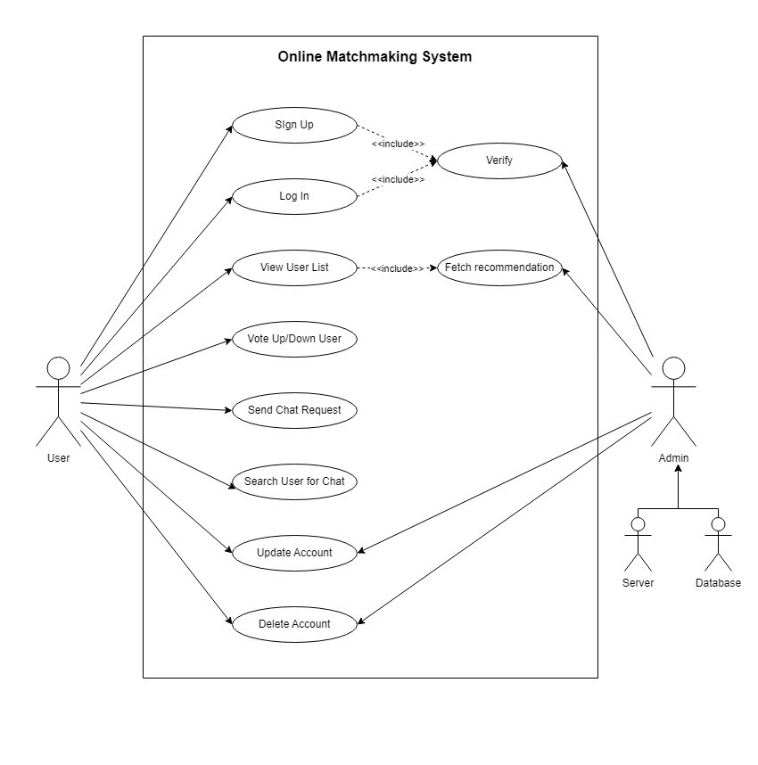

**Figure 1 Use Case Diagram**

The use case diagram represents the functionality and interaction of the online matchmaking application. It illustrates the various actors, use cases and their relationships.

1. Actors:
   * User: Represents individuals who use the application.
   * Admin: Represents the system backend who or the database.
2. Use Cases:
   * Register/Login: Users can create an account by registering with their details and subsequently log in to access the application's features.
   * View Recommended Profiles: Users can view a list of recommended profiles generated by a recommendation algorithm.
   * Vote Up/Down Profiles: Users can express their preference for a profile by voting it up or down.
   * Send Connection Request: Users can send connection requests to profiles they are interested in.
   * Accept/Decline Connection Request: Users can accept or decline connection requests received from other users.
   * Chat: Connected users can engage in chat conversations with each other.
   * Search Users: Users can search for other users based on specific criteria, such as interests.
   * Manage Profile: Users can view and update their profile information, including personal details and interests.
   * Delete Account: Users can request the deletion of their account, which is handled by the admin system.
   * Verify Signup/Login: The admin system verifies the signup and login process of users.
   * Update User Profile: The admin system can update user profiles if necessary.

### 3.1.2 NON FUNCTIONAL REQUIREMENTS

Some of the non-functional requirements of the proposed system are listed below:

* Performance: The application should be responsive and provide quick response times.
* Security: The application should implement appropriate security measure to protect user data, including encryption of sensitive information, secure authentication and authorization mechanism.
* Reliability: The application should be reliable and available for users.
* Privacy: The application should respect user privacy and comply with data protection regulations etc.
* Maintainability: The application should be developed using clean and modular code practices allowing for easy maintenance and future enhancements.

## 3.2 FEASIBILITY STUDY

### 3.2.1 ECONOMICAL FEASIBILITY

Through the use of open source technology in its development, the resource for the development process of the proposed system is minimal but the effort is above the normal standard. The frameworks, modules, and IDE that will be used are available for free. This system opens a wide range of areas and can replace much other software through its further implementation

### 3.2.2 TECHNICAL FEASIBILITY

We have identified the necessary hardware, software, and development resources to build the service, and we believe that we can deliver the desired features and capabilities. The programming language and tools that we used are JavaScript, Flutter, Node.js.

### 3.2.3 OPERATIONAL FEASIBILITY

We have conducted an operational feasibility analysis and have concluded that our work in feasible in this sector. We have the necessary infrastructure, skills, training and our system is in compliance with all relevant laws and regulations

### 3.2.4 SCHEDULE FEASIBILITY

In the first month of the project, we will define the scope and objectives of the online matchmaking application, conduct market research to assess demand and competition, identify technical and resource requirements, and create a project budget and timeline. In the second month, we will develop a prototype of the application, conduct user testing to gather feedback and make necessary improvements, finalize the design and functionality of the application, and begin building and integrating necessary features. In the third month, we will complete development of the application, conduct final testing and debugging, launch the application, and prepare the necessary documentations.

# CHAPTER 4: SYSTEM DESIGN

## 4.1 FLOW CHART

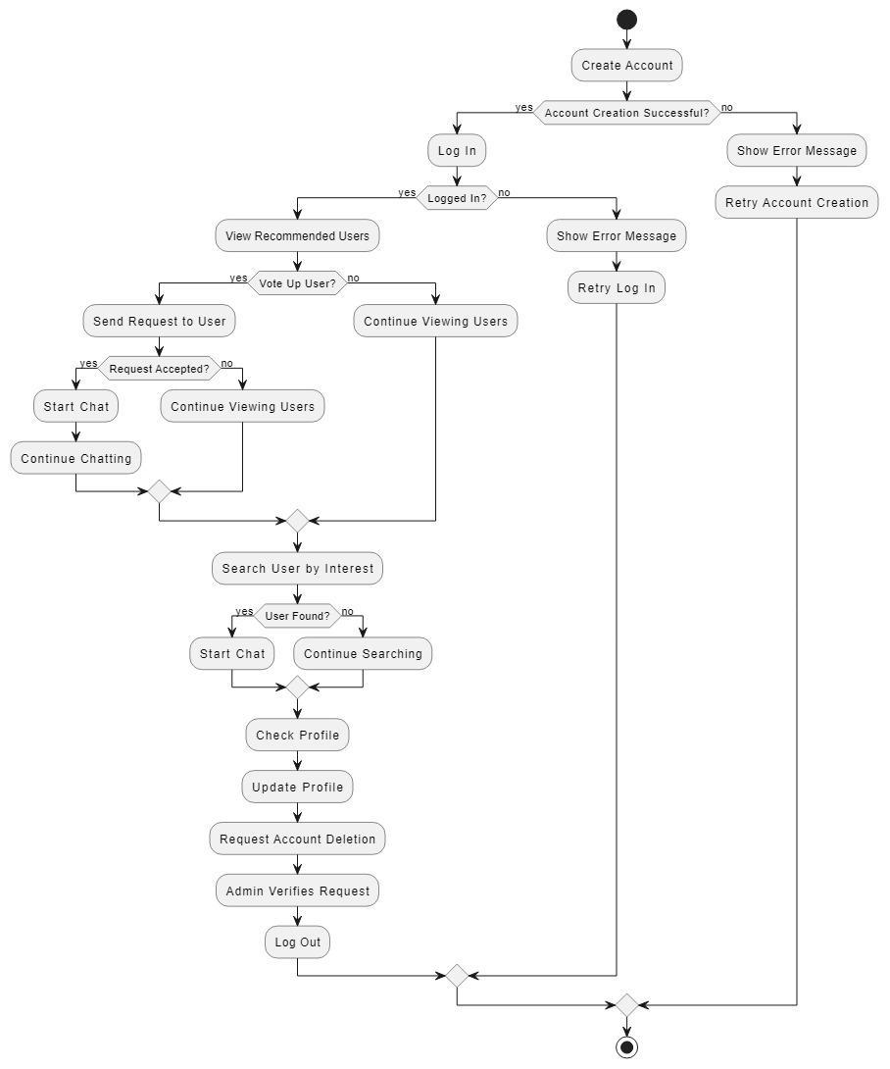

**Figure 2 Flow Chart**

The flow chart represents the sequential steps and decision points involved in the user interaction within the online matchmaking application.

It starts with the user registration process, where new users create their accounts by providing the necessary information. Once registered, users can log into the application using their credentials. After logging in, users are presented with a list of recommended matches based on a algorithm. They can then choose to either vote up or down the displayed profile. If a user votes up another user, a notification is send to that user indicating the interest. The other user can then choose to accept or decline the request. The users have the option to search for specific users based on their input interest and chat with them directly.

Users can also access their profile where they can view and update their personal information and preferences. Additionally, users have the ability to request account deletion, which is handled by the system. The admin system plays a role in verifying the user login and signup processes. It also has the authority to delete/update profiles if necessary.

## 4.2 SEQUENCE DIAGRAM

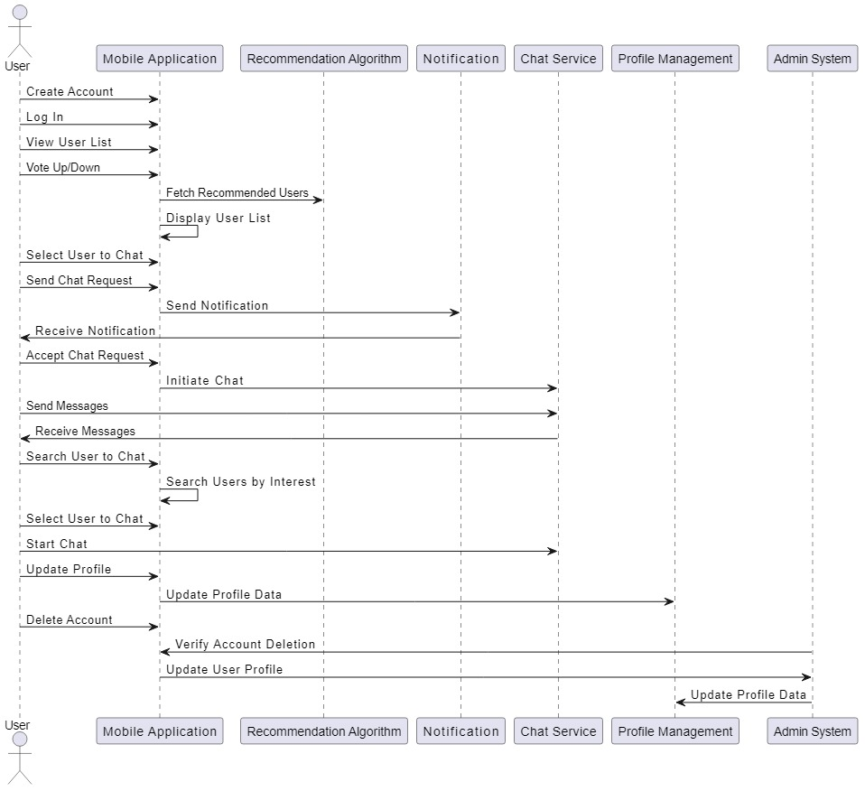

**Figure 3 Sequence Diagram**

The sequence diagram illustrates the interaction and sequences of events between different components and actors in the online matchmaking application.

It starts with the user initiating the registration process by providing their details. The system validated the information and creates a new user account. Once registered, the user can log into the application using their credentials. After logging in, the user interacts with the system by viewing the recommended matches. The user can then vote up or down a profile.

If the user votes up a profile, a request notification is sent to the other user. The notification is received by the targeted user, who can then accept or decline the request. If the request is accepted, both users are allowed to start a chat session. Alternatively, the user can choose to search for other users based on their input interest. The system provides a search functionality that allows users to find specific user to find specific profiles matching criteria.

The user also has access to their profile, where they can view and update their personal information and preferences.

The admin system plays role in verifying the user login and signup process. It also has the authority to update/delete profile if necessary.

The sequence diagram provides a visual representation of the chronological order and interaction between different components and actors in the application, showcasing the flow of actions and information during the user journey.

# CHAPTER 5: IMPLEMENTATION AND TESTING

## 5.1 IMPLEMENTATION

The proposed system aims to implement various tools and a recommendation algorithm to function properly.

### 5.1.1 TOOLS USED

1. Flutter: Flutter is a mobile application development platform developed by Google. It allows developers to create web, desktop and cross-platform apps that run on Android and IOS devices. We have used this to make app structured and scalable.
2. Node.js: Node.js is an open-source, cross-platform JavaScript runtime environment.
3. Express.js: We used express, a node.js web application framework to create API and services for our application in the frontend.
4. Mongoose: We have used Mongoose library on node as an ORM to manipulate database and model our application.
5. MongoDB: MongoDB is a NoSQL database program. It uses JSON-like documents with optional schemas.
6. Socket.io: We have used socket.io, an event-driven library, for real time communication between frontend and backend. It helped us achieve real time chatting system.
7. Version Control: Tools like Git and GitHub are employed for version control for team collaboration, tracking changes and managing code efficiently.

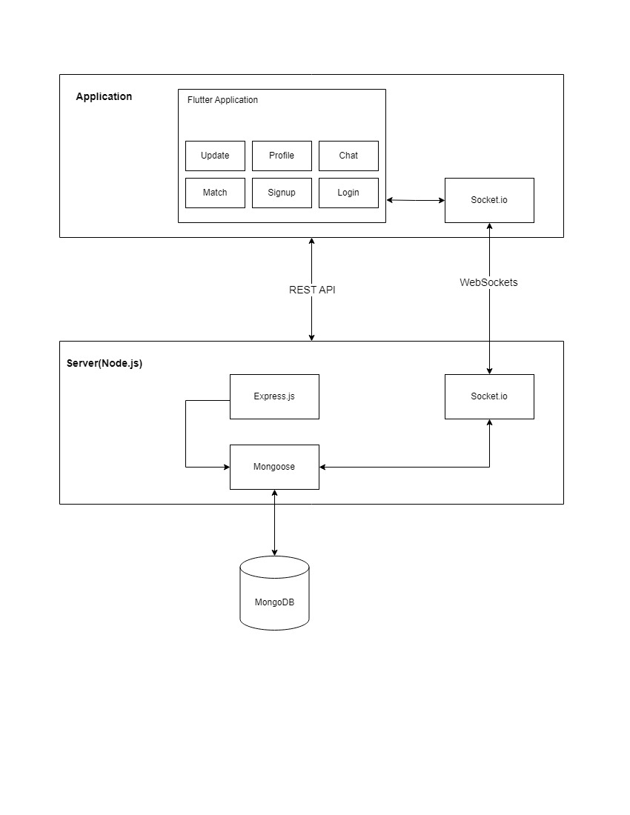

**Figure 4 Block Diagram of Tools Used**

### 5.1.2 ALGORITHM

**User recommendation algorithm**

The recommendation algorithm employed in our project follows these steps:

1. Obtain a list of users whom the current user has expressed interest in, referred to as N.
2. Retrieve a list of users who have shown interest in people from list N, denoted as N'.
3. Fetch a list of users who have shown interest in people from list N', denoted as N''.
4. Combine the users who are not included in N'' based on the current user's gender preferences. This step ensures that the recommended users align with the current user's specified gender interests.
5. Append the filtered list of users from the previous step to N''. This results in an extended list, denoted as N''', which includes users who share mutual interests with the current user and also meet the gender preferences.
6. Apply any additional filtering criteria to further refine the list of potential matches in N''' if necessary.
7. Sort the refined list of potential matches based on scores.
8. Present the resulting list to the current user for viewing and interaction.
9. End.

This algorithm further ties with the **Matching algorithm** given below:

1. Allow the user to interact with the recommended users, providing the options for voting up or down on each profile.
2. Notify the recommended users when they receive a vote up from the current user, enabling them to decide whether they want to connect and initiate a chat.
3. Add both of the users in their respective chat list which enables chat functionality.
4. End.

By implementing this algorithm, the system aims to provide the current user with a curated list of potential matches based on their expressed interests and the interests of other users. The algorithm leverages user preferences and mutual interests to enhance the matchmaking process, facilitating meaningful connections between users.

## 5.2 TESTING

### 5.2.1 UNIT TESTING

Unit testing is the level of software testing of the project’s system in which the smallest testable parts of a system called unit is individually tested. Unit testing concentrates on each unit of the system as implemented in the source code. The main purpose of unit testing is to validate each unit of the software to perform as designed.

**Table 1 Test Cases for Unit testing**



### 5.2.2 SYSTEM TESTING

The system testing part of a testing methodology involves testing the entire system for errors and bugs. This test is carried out by interfacing the hardware and software components of the entire system, and then testing it as a whole.

**Table 2 Test cases for system testing**



# CHAPTER 6: CONCLUSION AND FUTURE RECOMMENDATIONS

## 6.1 CONCLUSION

In conclusion, our project, online matchmaking application, aims to provide users with a platform to find and connect with potential matches. Throughout the development process, we focused on creating a user-friendly interface, implementing essential features, and ensuring the security and privacy of our users. We successfully designed and implemented functionalities such as user registration and login, recommendation algorithms for matching users, chat functionality, profile management, and account deletion. These features enable users to create profiles, search for matches based on their interests, initiate connections, and engage in meaningful conversations.

Although our project is the result of our initial foray into system development, we are proud of the progress we have made. While there are certain limitations, such as the location based filtering and refinement of the algorithms, we believe that Renai has the potential to address the trust issues surrounding foreign matchmaking applications in Nepal.

Overall, our project demonstrates our ability to conceptualize and develop a functional online matchmaking application while considering user needs, system performance, and security. Through this project, we have gained valuable experience in software development and have a solid foundation for future endeavors in creating innovative and user-centric applications.

## 6.1 FUTURE RECOMMENDATIONS

The current system is limited to providing its services only in English language at the moment. However, we believe that the system can be further enhanced to include local language. We are also hoping to add several praiseworthy feature like:

1. Enhanced Recommendation Algorithm
2. Advanced Search filters
3. Expand platform compatibility
4. Social media integration

# REFERENCE

[1] Kyla Scanlon (Sep 1, 2020). Dating Data: An Overview of the Algorithm. Medium. [*https://medium.com/swlh/dating-data-an-overview-of-the-algorithm-afb9f0c08e2c*](https://medium.com/swlh/dating-data-an-overview-of-the-algorithm-afb9f0c08e2c)

[2] Cambre, C. & David, G. (2016, April 5). Screened intimacies: Tinder and the swipe logic. Social Media + Society, 2(2). Retrieved from [*http://journals.sagepub.com/doi/abs/10.1177/2056305116641976*](http://journals.sagepub.com/doi/abs/10.1177/2056305116641976)

[3] Hussain Habibullah (Jun 12, 2022). Flutter: Integrating Socket IO Client

[*https://medium.com/flutter-community/flutter-integrating-socket-io-client-2a8f6e208810*](https://medium.com/flutter-community/flutter-integrating-socket-io-client-2a8f6e208810)

[4] “UML Use Case Diagram Tutorial”. Lucid chart. Retrieved from

[*https://www.lucidchart.com/pages/uml-use-case-diagram*](https://www.lucidchart.com/pages/uml-use-case-diagram)

# APPENDICES

### SCREENSHOTS

### 

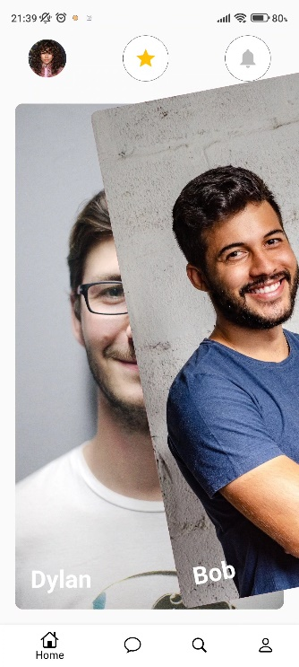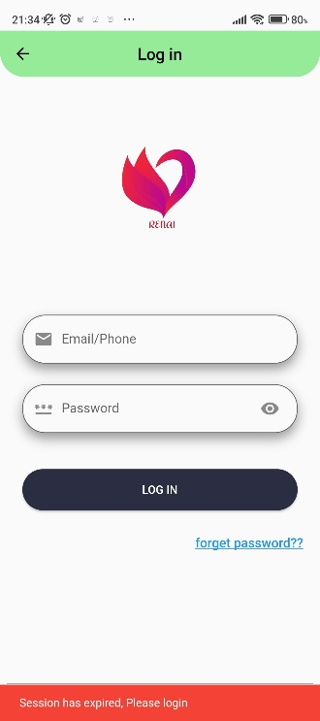

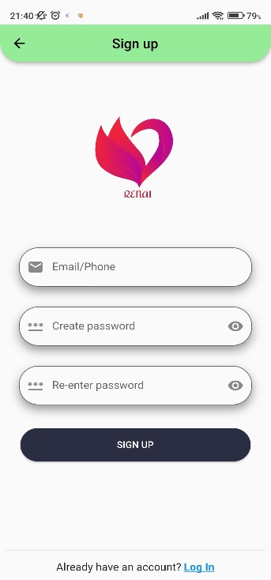

Homepage

Signup page

Login page

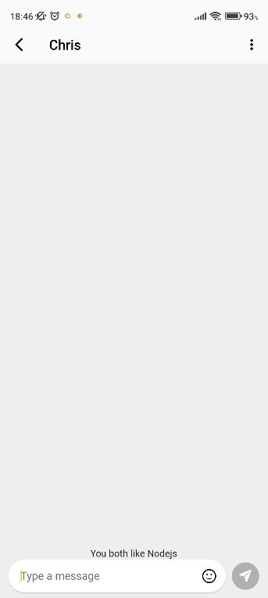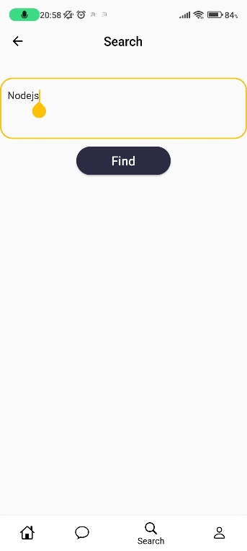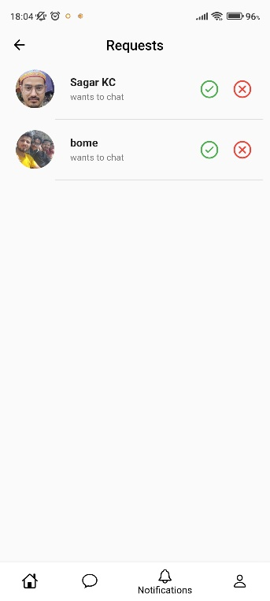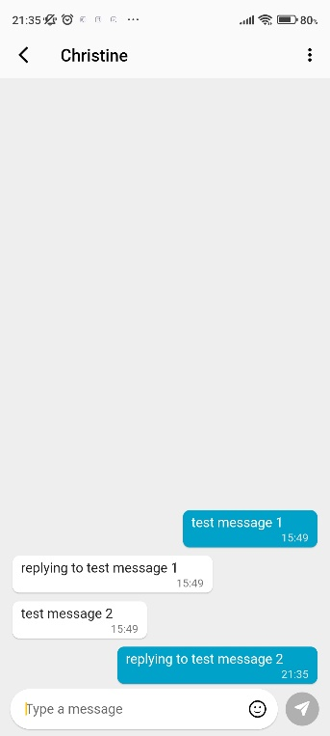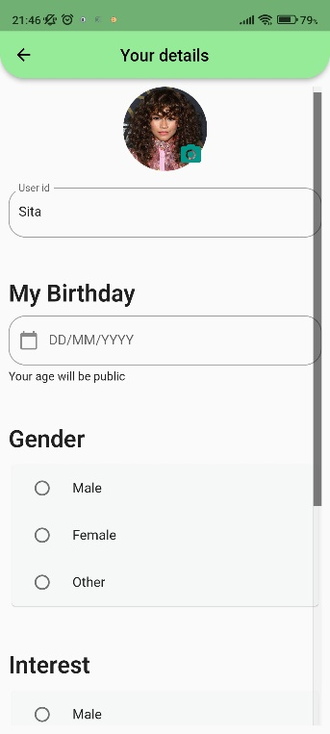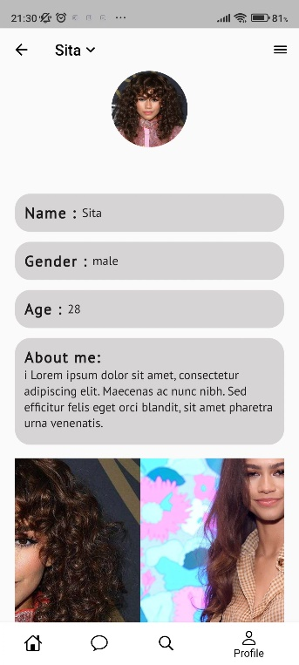

Profile page

Profile page

Profile page

Chat page

Update page

Profile page